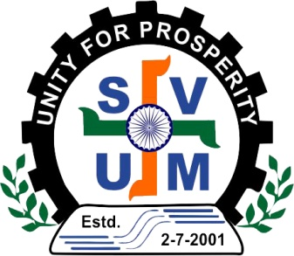
Saurashtra Vepar Udyog Mahamandal
304-Rajat, Sardarnagar Main Road,
Rajkot, Gujarat (India)-360001
Mobile: +91 9426254611 Email: president.svum@gmail.com

Registration Form for Foreign Delegate
SVUM - 2024 International Trade Show at Rajkot – Gujarat - India.
Date: 11th to 15th February, 2024

(Please send file in word or pdf document only, don’t send scanned copy)

Tell us about yourself

Name of Applicant :
(As in Passport)
Gender :
Company Name :
Your Designation :
Mobile No. :
Do you have reliable internet connection?
Whatsapp Number: Skype ID:
Other:
Passport No :
Date of Birth :
Country of Origin :
Date of Issue :
Date of Expiry :
Do you need Invitation letter for Visa? Yes [ ] No [ ]
Application for Visa: From Date: To Date:

Your company’s annual turnover over (in USD):

What type of Business you are doing :

List of Products which you want to Buy/Purchase:

List of Products which you want to sell:

Tell us About Your Company

Company Name :
Address :

City :
Country :
Phone with ISD code/ :
Mobile :
Fax :
Email :
Web site :
Import License number (Mandatory):
Annual year 2022 import figures in USD (Mandatory):
How you came to know about this trade show? (Name of representative / media):

Terms & Conditions:
- Bring samples, Brochure visiting cards, your profile, CDs in enough quantity.
- Please attach scanned copy of your passport.
- Send this document file to president.svum@gmail.com
- We are providing accommodation from 10th February 2024 (Check in after 12 noon) to 15th February, 2024 (Check out before 12 noon) on double sharing.
- Any delegates coming prior to this time period or staying after this period have to pay for accommodation and all other extra charges.
- Accommodation package includes breakfast facility only All other services are payable, Lunch and dinner will be provided at B2B meeting venue or during factory visits as planned by organiser.
(Food Package Applicable Only 5 Breakfasts, 4 Lunches & 4 Dinners (During 11th to 15th February, 2024)
- All delegates are supposed to attend all B2B meetings, Seminars and Factory visits as planned and informed by organiser. If you have any specific plans please inform well in advance. So that we can guide/arrange for you, If we find you are joining meeting or factory visit apart from SVUM without information, you will disqualified to avail any benefits of SVUM.
- We are providing pick up and drop facility from Rajkot Airport, You can come to Rajkot via Ahmadabad or via Mumbai.
- Read offer letter/document for more clarity.
- We are providing vegetarian food.

Deadline dates Rajkot:-
Last date to submit registration form. – 15th January 2024 (First come First Served)
Last date to apply from Visa. 25th January, 2024
Last date to inform about travel plans with confirmed tickets. 5th January 2024
Reporting date at Rajkot. 10th / 11th February, 2024
Last date for complimentary accommodation 11th February, 2024

Document Required for Registration:-
1. Copy of Passport
2. Copy Membership Certificate of Association/Chamber
3. Copy of Import license of your company. (Mandatory)
4. Certificate of Import of your company during Last Financial year, Figures in USD.
5. Passport size Photograph.
6. eBrochures of your company.
7. Visiting/Business Card.

.....................................................................................................
Name & Signature of Delegate with Company Seal

