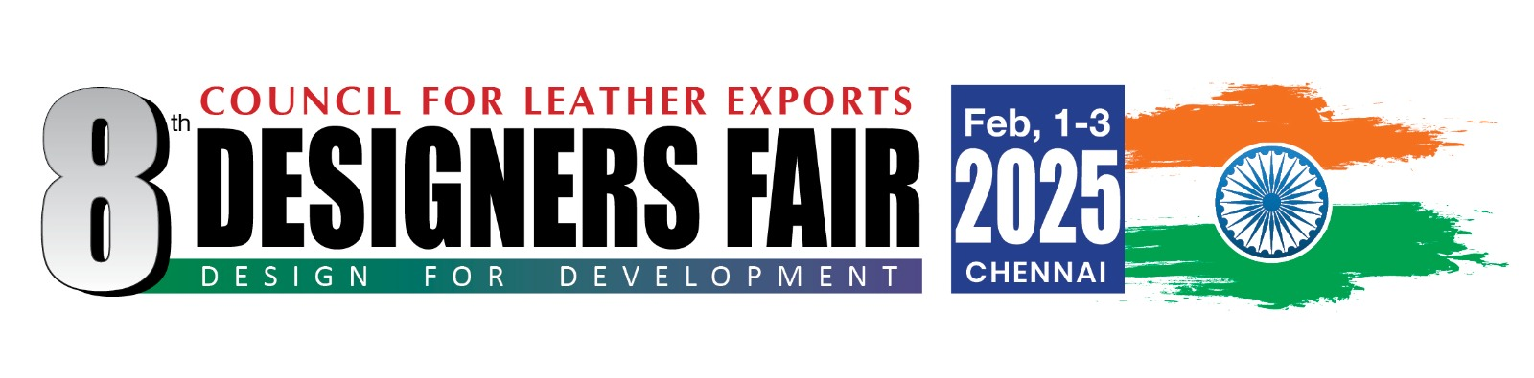
Designers Fair, Feb. 1 – 3, 2025, Chennai
PACKAGE FOR DESIGNERS

- Sponsorship of return Air Ticket subject to ceiling of Euro 800 for Europe and USD 1500 for USA per Designer and USD 450 for Asia

- Free Hotel Accommodation for 4 nights from Jan. 31- Feb. 3, 2025 + facility for early check-in (i.e. check-in prior to 12 noon of January 31, 2025 in case of early arrival of flights). Arrival can be planned in the morning/afternoon of Jan. 31, 2025. Only bed and breakfast are covered in hotel accommodation. Additional charges for use of SPA, room service, restaurant, bar, mini-bar in the room, gymnasium etc., will have to be borne by the designers.

- Complimentary Airport-pick-up and Drop

- Complimentary breakfast (included in hotel package) from Feb. 1-3, 2025 and lunch from Feb.1 - 3, 2025. Complimentary Dinner on February 1 & 2, 2025.

- Complimentary Fully Constructed Stand of 9 sq.mtr for displaying Design Projects/ Products which will include Name Board, Spot Lights, Shelves/Rails, Carpeting, One Table and 3 Chairs. The stand will be a closed stand.

- Visa recommendation letter from Council for Leather Exports

- No restrictions on the type of samples to be carried. Designers can carry samples for the fall /winter 25 or spring /summer 26 season or any innovative and appropriate designs.

**********

