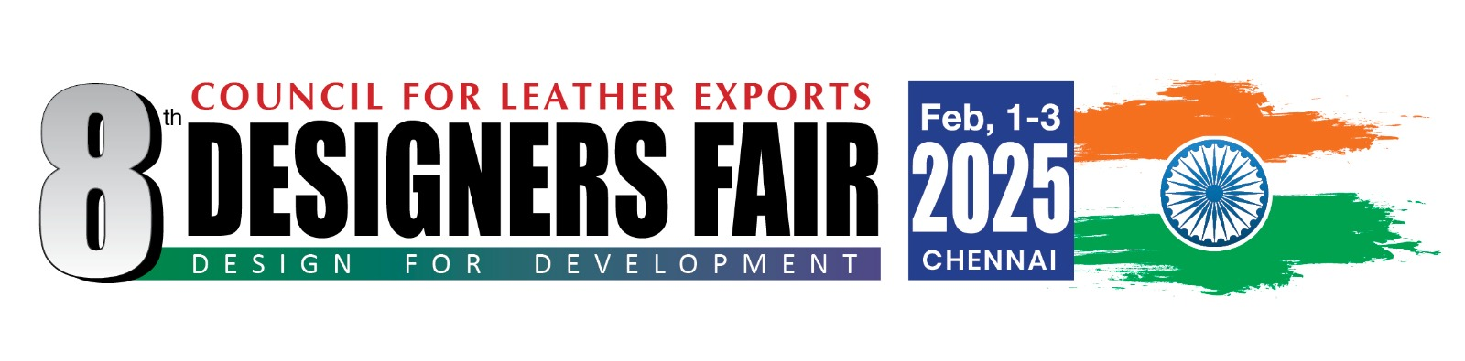8th Designers Fair, Feb. 1-3, 2025
Organised by
COUNCIL FOR LEATHER EXPORTS
(Sponsored by Ministry of Commerce & Industry, Govt. of India)

APPLICATION FORM FOR DESIGNERS

Name of the Company

Name of the Designer

Address

Phone

Fax

e-mail

Website

Name of the Designer Attending the Fair

Design Prototypes/ Products to be displayed and sold in the fair
(Season, Products covered etc.,)

Major achievements of the Designer in the past (working with brands, awards received, innovations done etc.,) .

Brief History of your company/
Designer Profile

Passport details of Designer attending the Show
Name as per Passport
Date of birth
Passport Number
Date of Issue
Date of Expiry
Place of Issue
Bank Account Details of Designer

Account Holder Name

Account Number

Bank Name

Bank Address

IBAN Number

SWIFT Code

Along with the application, please send the following.

Please send copy of your passport page containing photo and passport number

Please send 4-5 Product photographs designed by you (Soft copy)

SIGNATURE & NAME :

DESIGNATION :

DATE :

Note : Please send the application form (scanned copy/soft copy) by e-mail to gokul@cleindia.com along with Design Photographs (4-5 nos) and passport copy.

